Software
Design Model
for the
TRee EDitor (TRED) Project
Developed in CEN 5016

Submitted by

Doug Hathaway
Justin Griffin
Robert Shade
Mark Young

April 24, 2005
Table of Contents

1 Introduction 1
1.1 Document Purpose 1
1.2 Document Scope 1
1.3 Definitions, Acronyms, and Abbreviations 1
1.4 References 2
1.5 Document Overview 2
2 Overview and Summary of the Simulation System 3
2.1 Project Motivation and Business Analysis 3
2.2 Operational Concept and Functional Capabilities 4
2.2.1 System Actors and Use Cases 4
2.2.2 Assumptions and Dependencies 5
3 Use Case Specifications 6
3.1 Load Program 6
3.2 Create New Program 7
3.3 Select View 8
3.4 Close Program 8
3.5 Cut Program Element 9
3.6 Copy Program Element 10
3.7 Delete Program Element 11
3.8 Insert New Program Element 12
3.9 Paste Program Element 13
3.10 Paste From Clipboard 14
3.11 Edit Program Element 15
3.12 Save Program 16
3.13 Save Program As 17
3.14 Export to Java 18
3.15 Hide Program Element 19
3.16 Unhide Program Element 20
4 External Interface Specifications 22
4.1 Input Specifications 22
4.2 Output Specifications 23
4.3 GUI Specifications 23
5 Internal Software Specifications 29
5.1 Architectural Overview 29
5.2 Package Specifications 33
5.2.1 Package: tred.codegenerator 33
5.2.2 Package: tred.codegenerator.java 34
5.2.3 Package: tred.datastructures 34
5.2.4 Package: tred.gui 34
5.2.5 Package: tred.javaexport 34
5.2.6 Package: tred.xml 34
5.3 Database Specifications 34
5.4 Class Specifications 35
5.4.1 Classes in Package tred.codegenerator 35
5.4.1.1 CodeClass 36
5.4.1.2 CodeClassCollection 36
5.4.1.3 CodeCompileUnit 36
5.4.1.4 CodeConstructor 37
5.4.1.5 CodeConstructorCollection 37
5.4.1.6 CodeDestructor 37
5.4.1.7 CodeField 37
5.4.1.8 CodeFieldCollection 38
5.4.1.9 CodeGenerator 38
5.4.1.10 CodeMember 38
5.4.1.11 CodeMethod 38
5.4.1.12 CodeMethodCollection 39
5.4.1.13 CodeMethodParameter 39
5.4.1.14 CodeMethodParameterCollection 39
5.4.1.15 CodePackage 40
5.4.1.16 CodePackageCollection 40
5.4.1.17 CodePackageReference 40
5.4.1.18 CodePackageReferenceCollection 40
5.4.1.19 TypedAbstractCollection 41
5.4.2 Classes in Package tred.codegenerator.java 41
5.4.2.1 JavaCodeGenerator 41
5.4.3 Classes in Package tred.datastructures 42
5.4.3.1 Node 42
5.4.3.2 JavaProgNode 44
5.4.3.3 PackageNode 44
5.4.3.4 ClassNode 44
5.4.3.5 MethodNode 45
5.4.3.6 MemberVarNode 45
5.4.3.7 NodeDisplayInfo 46
5.4.4 Classes in Package tred.gui 47
5.4.5 Classes in Package tred.javaexport 47
5.4.5.1 JavaExporter 47
5.4.6 Classes in Package tred.xml 47
5.4.6.1 XMLExport 48
5.4.6.2 XMLImport 49
6 Implementation Summary 50

List of Figures
Figure 1-1 Example Java Program Tree 4
Figure 3.1-1 Load Program Collaboration Diagram 6
Figure 3.2-1 New Program Collaboration Diagram 7
Figure 3.3-1 Select View Collaboration Diagram 8
Figure 3.4-1 Close Program Collaboration Diagram 8
Figure 3.5-1 Cut Program Element Collaboration Diagram 9
Figure 3.6-1 Copy Program Element Collaboration Diagram 10
Figure 3.7-1 Delete Program Element Collaboration Diagram 11
Figure 3.8-1 Insert Program Element Collaboration Diagram 12
Figure 3.9-1 Paste Program Element Collaboration Diagram 13
Figure 3.10-1 Paste From Clipboard Collaboration Diagram 14
Figure 3.11-1 Edit Program Element Collaboration Diagram 15
Figure 3.12-1 Save Program Collaboration Diagram 16
Figure 3.13-1 Save Program As… Collaboration Diagram 17
Figure 3.14-1 Export to Java Collaboration Diagram 18
Figure 3.15-1 Hide Program Element Collaboration Diagram 19
Figure 3.16-1 Unhide Program Element Collaboration Diagram 20
Figure 4.3-1 Main GUI interface for TRED 24
Figure 4.3-2 TRED File Menu 24
Figure 4.3-3 TRED Edit Menu 25
Figure 4.3-4 TRED Context Menu 25
Figure 4.3-5 TRED Add Node Dialog 26
Figure 4.3-6 TRED Edit Node Dialog 26
Figure 4.3-7 Save Program Tree Dialog 27
Figure 4.3-8 Load Program Tree Dialog 27
Figure 4.3-9 Export to Java Dialog 28
Figure 5.1-1 Component Architecture of the TRED system 29
Figure 5.1-1 Opening a New Program Tree 30
Figure 5.1-2 Loading Program Tree 31
Figure 5.1-3 Saving a Program Tree 31
Figure 5.1-4 Exporting a Program Tree to Java Code 32
Figure 5.1-5 Cutting/Copying a Sub-Tree 32
Figure 5.1-6 Pasting a Sub-Tree 33
Figure 5.1-7 Pasting a Sub-Tree Using the Clipboard 33

List of Tables
Table 5.4.1.1-1 CodeClass Class Interface 36
Table 5.4.1.3-1 CodeCompileUnit Class Interface 36
Table 5.4.1.4-1 CodeConstructor Class Interface 37
Table 5.4.1.6-1 CodeDestructor Class Interface 37
Table 5.4.1.7-1 CodeField Class Interface 37
Table 5.4.1.9-1 CodeGenerator Class Interface 38
Table 5.4.1.10-1 CodeMember Class Interface 38
Table 5.4.1.11-1 CodeMethod Class Interface 39
Table 5.4.1.13-1 CodeMethodParameter Class Interface 39
Table 5.4.1.15-1 CodePackage Class Interface 40
Table 5.4.1.17-1 CodePackageReference Class Interface 40
Table 5.4.1.19-1 TypedAbstractCollection Class Interface 41
Table 5.4.2.1-1 JavaCodeGenerator Class Interface 41
Table 5.4.3.1-1 Node Class Interface 42
Table 5.4.3.2-1 JavaProgNode Class Interface 44
Table 5.4.3.3-1 PackageNode Class Interface 44
Table 5.4.3.4-1 ClassNode Class Interface 44
Table 5.4.3.5-1 MethodNode Class Interface 45
Table 5.4.3.6-1 MemberVarNode Class Interface 45
Table 5.4.3.7-1 NodeDisplayInfo Class Interface 46
Table 5.4.5.1-1 JavaExporter Class Interface 47
Table 5.4.6.1-1 XMLExport Class Interface 48
Table 5.4.6.2-1 XMLImport Class Interface 49

Introduction

Document Purpose

TRED is an interactive Java software engineering environment exploiting the state-of-the-art technology in incremental graph presentation and layout. This document defines a software implementation which fulfills the requirements laid out in the Use Case Model and other documents. Because of this, it is to be used as the framework for the software design of the TRED application.

Document Scope

The targeted user of this document is developers tasked with developing the TRED application software. While it does describe the functionality of the system on a technical level, it is not intended to be used by the User in place of a non-technical User Manual. In addition, this document can be used by the customer (Dr. Workman at the University of Central Florida) as a means of evaluating the final software implementation of the TRED application.

Definitions, Acronyms, and Abbreviations

Contextual Menu | A pop up menu activated by the right-click of a mouse over a node. It provides a selection of available operations that can be performed based on that node type.
GRXL | A XML based file format used to store trees and graphs. Documented in the FileFormats-Graphs.doc file supplied by the Customer.
Java | An Object Oriented programming language created by Sun Microsystems with the intent of being very portable.
Program Element (Element/Node) | An individual Java code element that is stored in the Tree. Each program element maps directly to one or more actual Java code statements. Possible types are: Program Node, Package Node, Class Node, Data Members Node, and Method Nodes.
SDK | Software Development Kit. A tool used for developing software of some form.
Shape Layout (Shape Algebra) | The algorithms which define the positioning and organization of the Tree and its Nodes.
TRED | The application which is being defined by this document. It will allow the user to generate a Java code design in the form of a Tree and export it out into actual compilable Java code.
Program  (Tree) | The hierarchy of program elements that comprises a valid Java program. The base of a complete Program is a Program Node which identifies the program being created.
View | A child window inside of the main application window. Each view contains exactly 1 tree.
XML | Short for eXtensible Markup Language. It’s a language used for storing and communicating data across in a structured format.

References

[1] TRee EDitor (TRED) Use Case Model, 17 March 2005, Hathaway, D., Griffin, J., Shade, R., Young, M.

[2] IEEE Recommened Practice for Software Requirements Specifications, IEEE Std 830-1998, 25 June 1998, IEEE-SA Standards Board

[3] An Incremental Tree Editor for Dynamic Hierarchical Drawing of Trees, 20 January 2004, Workman, D., Bernard, M., and Pothoven, S.

[4] Graph File Formats, Supplied by Dr. Workman in the file called FileFormats-Graphs.doc

Document Overview

The TRED applications software description follows. Section 2 covers higher-level requirements and interfaces to the application. Section 3 goes into more detail about the lower-level design and software architecture. It further defines how the architecture meets the requirements of the system laid out in the Use Case Model.

Overview and Summary of the Simulation System

Project Motivation and Business Analysis

There are currently very few CASE (Computer Aided Software Engineering) tools that allow developers to manipulate and analyze design as well as produce actual code. Tools of this nature are very useful because they enable developers to quickly and seamlessly step from the design process into implementation and test activities within the same development frame work; software engineers do not have to switch between tools produced by different vendors when they go from design to code and unit test. The goal of this project is to develop a prototype Java software engineering environment supporting both design and implementation activities through a user-friendly graphical interface.

The development of effective CASE tools is complicated by, and depends heavily on, the choice of target implementation language(s) they support. For example, languages such as C/C++ have so much variation in syntactic and semantic features and provide so much flexibility in program organization and structure, that it becomes extremely difficult to design a CASE tool capable of efficient and effective pre-code program analysis. Java, on the other hand, yields more readily to automated pre-code program analysis because of the structural and semantic restrictions it imposes; e.g., no gotos and no pointer arithmetic.
Because of Java’s clean structure and semantics, complete programs can be represented completely in the form of trees. That is, program building blocks and features have an inherently hierarchical relationship to one another. Not only does Java fully support the object-oriented paradigm as a program design style, the structure of language itself can be described in terms of OO concepts. Figure 1-1 illustrates the complete structure of a Java program expressed in the form of a UML (Unified Modeling Language) Class diagram.

Note that the structure is completely hierarchical (tree-formed) such that the first three structural levels can be viewed as the architectural design levels, the fourth and fifth levels as detailed design levels, and any levels beyond as purely implementation levels. Being able to define and edit the programs structure at any level within the same tool offers tremendous power and convenience to the Java program developer.
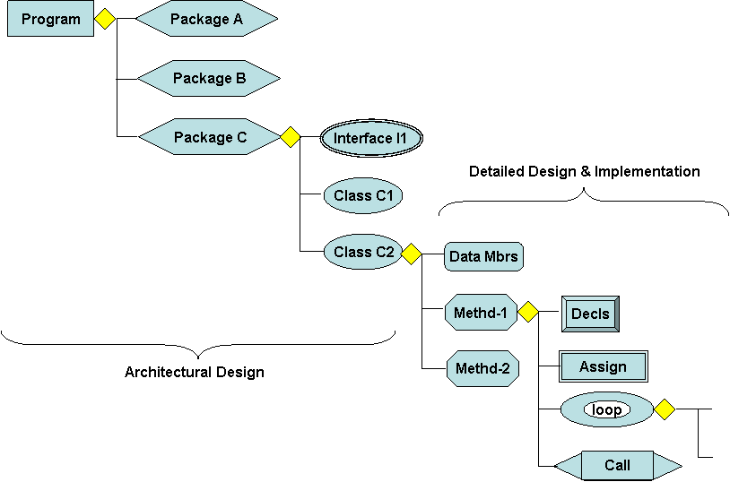
Figure 1-1 Example Java Program Tree

TRED is designed to allow users to develop Java programs by designing a tree structure that defines the program to be generated. Each tree, in its entirety, creates a Java program that is both correct and can be compiled. In addition, TRED provides tools that easily allow users to create components and link them together using the tree structure. The Program Node of the tree simple identifies the Program you are designing (and will be generating). Other node types that can be added to the Program Node include a Package Node and a Class Node. Each Class Node can then include nothing, a Data Member Node, or multiple Method Nodes. Refer to Figure 1-1 Example Java Program Tree.

Furthermore, to expand the product to meet a wider consumer base, this application is being designed to work on multiple computing platforms. The goal is to allow TRED to be run on any machine running with the appropriate Java run-time installed and the following operating systems: Microsoft Windows XP (SP1 and SP2), Apple OS X – Panther, and Mandrake Linux 10.0 (32-bit edition). Further operating systems should be functionally capable, but won’t be testable during this process of development.

Operational Concept and Functional Capabilities

System Actors and Use Cases
- Use Case Diagram
- Operational Narrative
- System State/Process Model
- External Interfaces
- Functional Requirements
- Non-Functional Requirement

Assumptions and Dependencies

To develop the TRED application, the lead architects have devised a common development environment for all developers to use. Developers must first be familiar with the Java language and Object Oriented concepts. This is required due to the fact that the entire TRED project will be written in Java. In addition, one developer should at least become familiar with the Xerces XML parsing libraries.

Due to the broad nature of the target environments for the end-user, developers may use any one or more of the following operating systems on their machines. Preferably, at least one developer will have a machine with each one of the target operating systems.
- Windows XP Service Pack 2
- Mac OS X – Panther
- Mandrake Linux 10.0 32-bit edition for i386 computers
The following applications must be installed on a developer’s machine:
- Java 2 SDK version 1.4.2-06
- Eclipse SDK version 3.0.1
- Xerces Java XML Library binaries version 2.6.2

Use Case Specifications

Load Program
ID: UC1
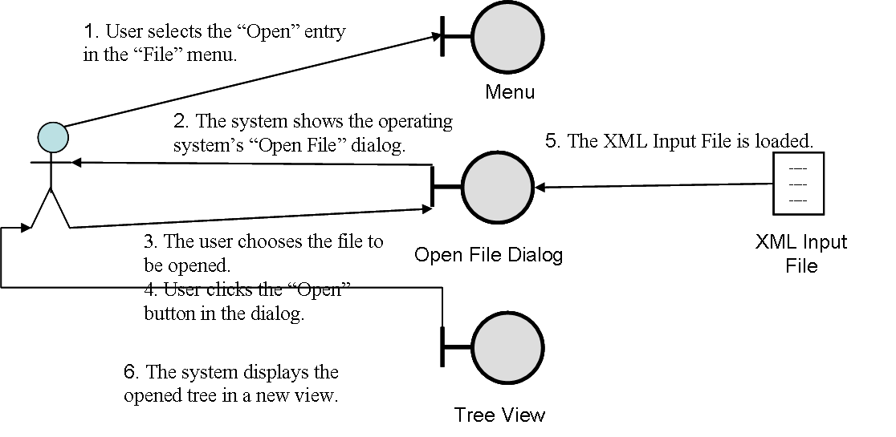
Figure 3.1-2 Load Program Collaboration Diagram

Purpose
The purpose of Load Program use case is to allow the user to Load an existing program from a file system.

Pre-Conditions
None.

Flow of Events
- User selects the “Open” entry in the “File” menu.
- The system shows the operating system’s “Open File” dialog.
- The user selects the file to be opened.
- User clicks the “Open” button in the dialog.
- The system loads the XML input file.
- The system displays the opened program in a new view.
- The new view is made the active view.

Alternate Paths
1a. User clicks in any area other than the menu.
- The use case terminates.
4a. The user has not selected a file.
- The system presents the user with an error dialog stating that the user must select a file.
- The user dismisses the dialog.
- Use case returns to step 3.
4b. The user clicks the “Cancel” button in the dialog.
- The user case terminates.
5b. The file selected was in an invalid format.
- The system presents the user with an error dialog stating that the file was in an invalid format.
- The user dismisses the dialog.
- The use case terminates.

Post Conditions
If a valid file was chosen, the system is focused on the new view. Else, the system follows an alternate path to use case termination and the system returns to the initial state before the use case.

Create New Program
ID: UC2
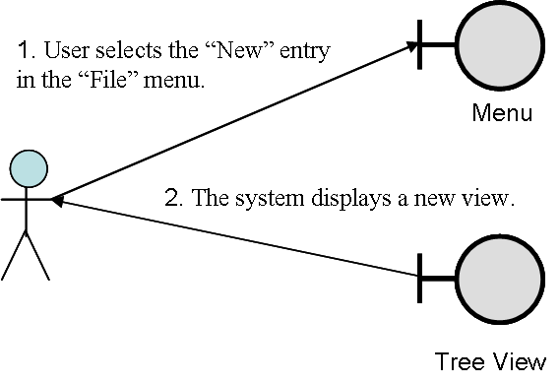
Figure 3.2-3 New Program Collaboration Diagram

Purpose
The purpose of the Create New Program use case is to allow the Editor User to create a new program.

Pre-Conditions
None.

Flow of Events
- The user selects “New” entry in the “File” menu.
- The system displays a new empty view composing of a root program element which can have other program elements added onto it.

Alternate Paths
1a. User clicks in any area other than the menu.
- The use case terminates.

Post Conditions
If the use case completes successfully, the system is focused on a new, empty view. Else, the system returns to the initial state before the use case.

Select View
ID: UC3
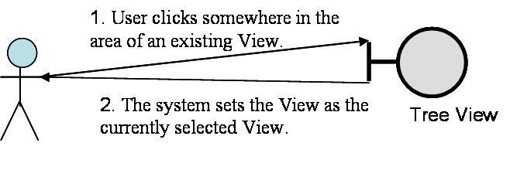
Figure 3.3-4 Select View Collaboration Diagram

Purpose
The purpose of the Select View use case is to allow the Editor User to select the active View.

Pre-Conditions
At least 1 view is active.

Flow of Events
- The user clicks somewhere in the area of an existing View.
- The system sets the View as the currently selected View.

Alternate Paths
1a. User clicks in any area other than a View.
- The use case terminates.
1b. User clicks in the currently selected View
- The use case terminates

Post Conditions
If the use case completes successfully, the system is focused on the selected view. Else, the system returns to the initial state before the use case.

Close Program
ID: UC4
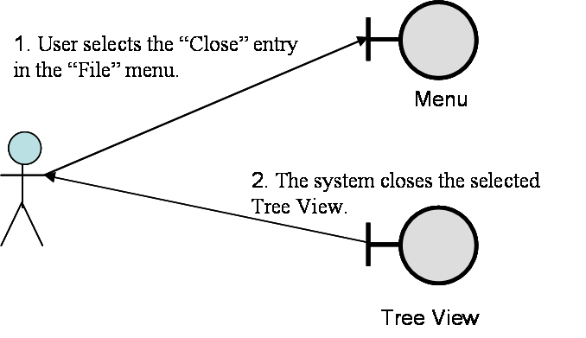
Figure 3.4-5 Close Program Collaboration Diagram

Purpose
The purpose of the Close Program use case is to allow the Editor User to close an existing Program.

Pre-Conditions
At least 1 view is active.

Flow of Events
- The user selects “Close” entry in the “File” menu.
- The system closes the currently selected Program.

Alternate Paths
1a. User clicks in any area other than a View.
- The use case terminates.
1b. User clicks on the X square in the upper right of the Window View border.
- The View whose border square was clicked is selected as the currently selected Tree View.
- Proceeds to step 2 of this Use-Case.

Post Conditions
If the use case completes successfully, the system closes the selected view. Else, the system returns to the initial state before the use case.

Cut Program Element
ID: UC5
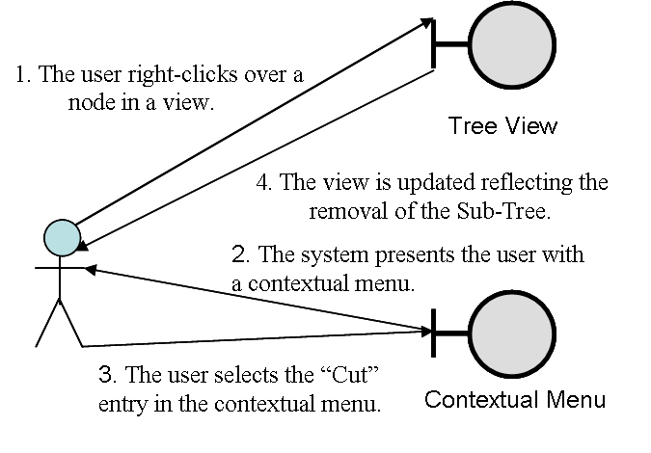
Figure 3.5-6 Cut Program Element Collaboration Diagram

Purpose
The purpose of Cut Program Element is to allow the user to remove a portion of the active program and place it on the clipboard.

Pre-Conditions
- A view is being displayed with a program with at least one program element.

Flow of Events
- The user right-clicks over a node in a view.
- The system presents the user with a contextual menu.
- The user selects the “Cut” entry in the contextual menu.
- The view is updated reflecting the removal of the Sub-Tree.
- The Sub-Tree is placed on the Clipboard as the most active item.

Alternate Paths
1a. The user selects “Cut” from the "Edit” menu continues at Step 4.
3a. The user clicks over any area other than a selection in the contextual menu.
- The use case terminates.

Post Conditions
- The active tree view reflects the sub-tree removal.
- The program element removed is added to the clipboard as the most recent item.

Copy Program Element
ID: UC6
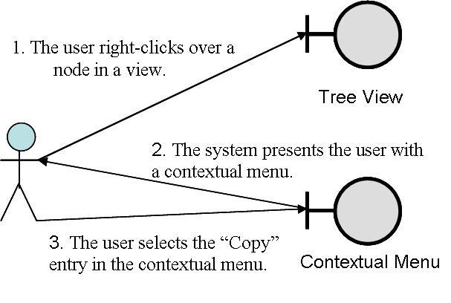
Figure 3.6-7 Copy Program Element Collaboration Diagram

Purpose
The purpose of Copy Program Element is to allow the user to copy a group of program elements to the clipboard.

Pre-Conditions
- A view is being displayed with a program with at least one program element.

Flow of Events
- The user right-clicks over a program element in a view.
- The system presents the user with a contextual menu.
- The user selects the “Copy” entry in the contextual menu.
- The Program Element is placed on the Clipboard as the most active item.

Alternate Paths
1a. The user selects “Copy” from the "Edit” menu continues at Step 4.
3a. The user right-clicks over any area other than a selection in the contextual menu.
- The use case terminates.

Post Conditions
If the use case was completed successfully, a copy of the program element and it’s sub-elements is placed on the clipboard as the most recent item. Else, the use case terminates and the system returns to the initial state before the use case.

Delete Program Element
ID: UC7
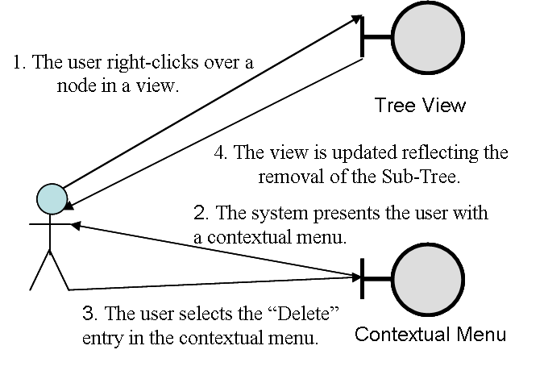
Figure 3.7-8 Delete Program Element Collaboration Diagram

Purpose
The purpose of Delete Program Element is to allow the user to remove a Program Element and it’s sub-elements from the active program view.

Pre-Conditions
- A view is being displayed with a program with at least one program element.

Flow of Events
- The user right-clicks over a node in a view.
- The system presents the user with a contextual menu.
- The user selects the “Cut” entry in the contextual menu.
- The view is updated reflecting the removal of the Sub-Tree.

Alternate Paths
1a. The user selects “Cut” from the "Edit” menu continues at Step 4.
3a. The user right-clicks over any area other than a selection in the contextual menu.
- The use case terminates.

Post Conditions
If the use case was completed successfully, the tree is updated to reflect the removal of the program element. Else, the use case terminates and the system returns to the initial state before the use case.

Insert New Program Element
ID: UC8
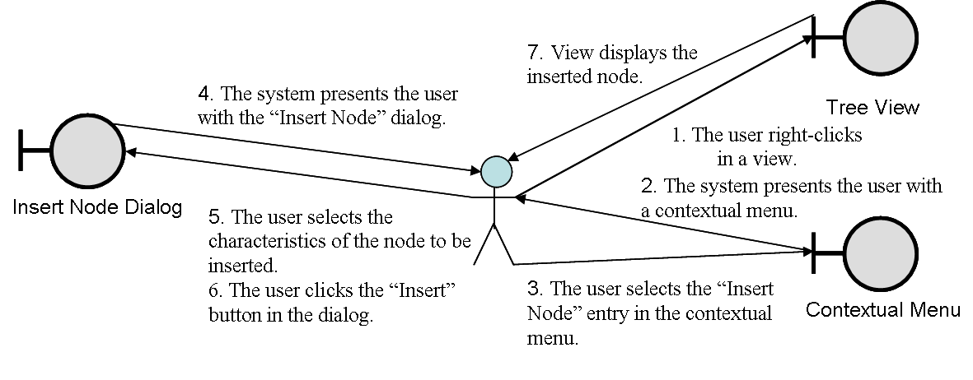
Figure 3.8-9 Insert Program Element Collaboration Diagram

Purpose
The purpose of Insert Program Element is to allow the user to add a program element to an existing program.

Pre-Conditions
- A view is being displayed.

Flow of Events
- The user right-clicks on the view.
- The system presents the user with a contextual menu.
- The user selects the “Insert Node” entry in the contextual menu.
- The system presents the user with the “Insert Node” dialog.
- The user selects the characteristics for the node to be inserted.
- The user clicks the “Insert” button in the dialog.
- The view displays the inserted node.

Alternate Paths
1a. The user selects “Insert Node” from the "Edit” menu continues Step 4.
2a. The tree contains nodes and the user did not right-click over a node.
- The “Insert Node” entry is disabled.
- The use case terminates.
2b. The tree contains nodes and the user right-clicked over one of them.
- The new node will be added as a child of the existing node.
- The use case continues at Step 3.
3a. The user clicks in any area other than the contextual menu.
- The use case terminates.
6a. The user clicks the “Cancel” button in the dialog.
- The node is not inserted and the use case terminates.
6b. The user clicks the “Ok” button but not all data has been filled in correctly.
- Dialog is displayed indicating that all the fields have not been filled in.
- Use case returns to step 5.

Post Conditions
If the use case was completed successfully, a new node is added to the tree (with the characteristics selected) at the location specified. Else, the use case terminates and the system returns to the initial state before the use case.

Paste Program Element
ID: UC9
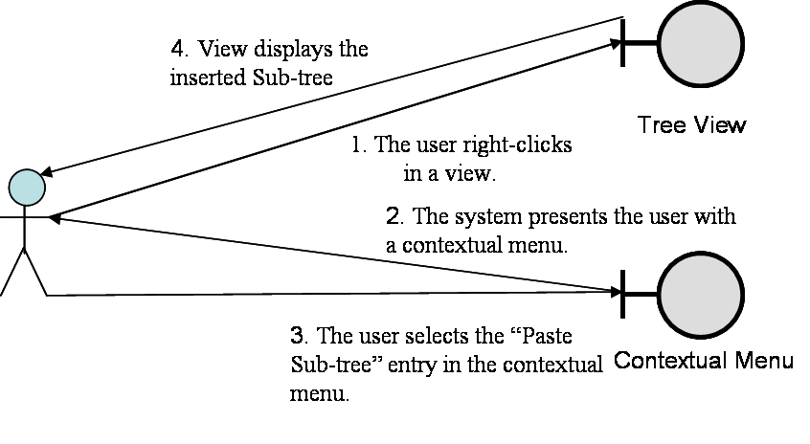
Figure 3.9-10 Paste Program Element Collaboration Diagram

Purpose
The purpose of Paste Program Element is to allow the user to insert the last Program Element that was previously cut or copied onto the Clipboard into the currently active tree.

Pre-Conditions
- A view is being displayed.
- The clipboard is not empty.

Flow of Events
- The user right-clicks on the view.
- The system presents the user with a contextual menu.
- The user selects the “Paste Sub-tree” entry in the contextual menu.
- The view displays the inserted Sub-Tree.

Alternate Paths
2a. The tree contains nodes and the user did not right-click over a node.
- The use case terminates.
3a. The user clicks in any area other than the contextual menu.
- The use case terminates.
4a. A warning is displayed indicating that the selected sub-tree can not be added to the specified area.
- The use case terminates.

Post Conditions
If the use case was completed successfully, a copy of the most recent item (sub-tree) from the clipboard is inserted into the currently active tree at the location specified. Else, the use case terminates and the system returns to the initial state before the use case.

Paste From Clipboard
ID: UC10
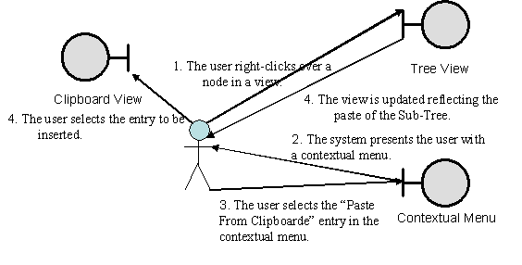
Figure 3.10-11 Paste From Clipboard Collaboration Diagram

Purpose
The purpose of Paste From Clipboard is to allow the user to insert a Sub-Tree from the clipboard into the currently active tree.

Pre-Conditions
- A view is being displayed.
- The clipboard is not empty.

Flow of Events
- The user right-clicks on the view.
- The system presents the user with a contextual menu.
- The user selects the “Paste from clipboard…” entry in the contextual menu.
- The system presents the user with the “Paste From Clipboard” dialog (Error: Reference source not found).
- The user selects the entry to be inserted.
- The user clicks the “Insert” button in the dialog.
- The view displays the inserted Sub-Tree.

Alternate Paths
2a. The tree contains nodes and the user did not right-click over a node.
- The “Paste from clipboard…” entry is disabled.
- The use case terminates.
2b. The tree contains nodes and the user right-clicked over one of them.
- The Sub-Tree will be inserted as a child of the existing node.
- The use case continues at Step 3.
3a. The user clicks in any area other than the contextual menu.
- The use case terminates.
6a. The user clicks the “Cancel” button in the dialog.
- The node is not inserted and the use case terminates.
6b. A warning is displayed indicating that the selected sub-tree can not be added to the specified area. Proceed back to Step 5.

Post Conditions
If the use case was completed successfully, a copy of the most recent item (sub-tree) from the clipboard is inserted into the currently active tree at the location specified. Else, the use case terminates and the system returns to the initial state before the use case.

Edit Program Element
ID: UC11
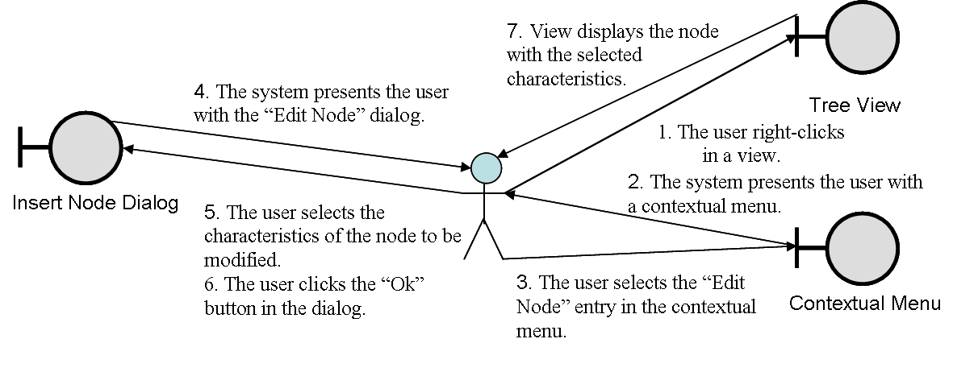
Figure 3.11-12 Edit Program Element Collaboration Diagram

Purpose
The purpose of the Edit Program Element use case is to allow the user to perform various editing functions for a node.

Pre-Conditions
A view is being displayed with a program with at least one program element.

Flow of Events
- The user right-clicks on the node to be edited.
- The system presents the user with a contextual menu.
- The user selects the “Edit Node” entry.
- The system presents the user with the “Edit Node” dialog.
- The user selects the characteristics to be modified.
- The user clicks the “Ok” button.
- The view redisplays the node with the selected characteristics.

Alternate Paths
1a. The user selects “Edit Node” from the "Edit” menu continues Step 4.
3a. The user clicks in any area other than the contextual menu.
- The use case terminates.
6a. The user clicks the “Cancel” button.
- No changes to the node are made and the use case terminates.
6b. The user clicks the “Ok” button but not all data has been filled in correctly.
- Dialog is displayed indicating that all the fields have not been filled in.
- Use case returns to step 5.

Post Conditions
If the use case was completed successfully, the selected node is updated to reflect the changes made to it in the use case. Else, the use case terminates and the system returns to the initial state before the use case.

Save Program
ID: UC12
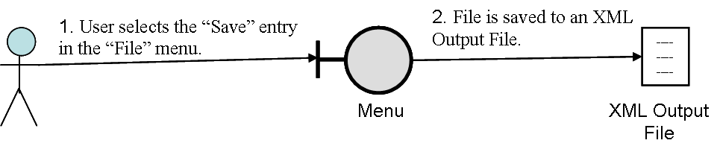
Figure 3.12-13 Save Program Collaboration Diagram

Purpose
The purpose of Save Program use case is to allow the user to save a program to its associated file.

Pre-Conditions
- A view is being displayed.

Flow of Events
- The user selects the “Save” entry in the “File” menu.
- The system writes the tree to the file.

Alternate Paths
1a. The view is not associated with a file.
- The use case proceeds to Step 2 of the Save Tree As use case.
2a. The storage area runs out of space or is not write-able.
1. The use case displays a warning dialog.
2. After user acknowledges warning dialog, the use case proceeds to Step 2 of the Save Program Element As use case.

Post Conditions
If the use case was completed successfully, the active program view is saved to a file. Else, the use case proceeds to step 2 of the Save Program As use case.

Save Program As
ID: UC13
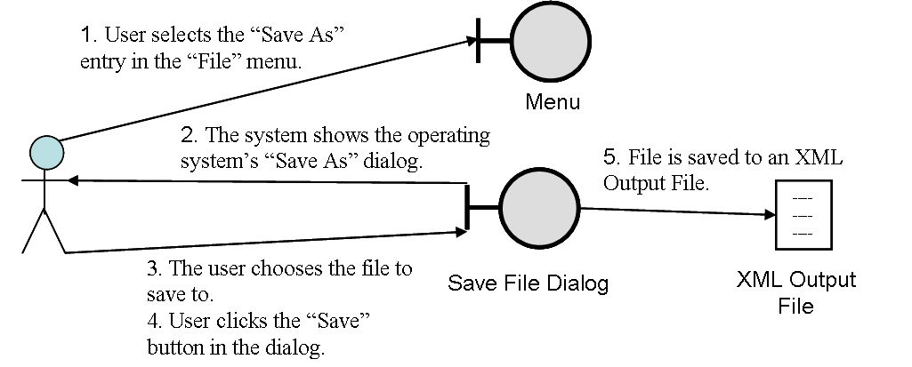
Figure 3.13-14 Save Program As… Collaboration Diagram

Purpose
The purpose of Save Program As… use case is to save a tree as a graph file in the GRXL file format. This format is a XML based file format that is used by other tree researchers. The file will be saved out with the extension “.grxl” appended to the user’s filename choice.

Pre-Conditions
- A view is being displayed.

Flow of Events
- The user selects the “Save As…” entry in the “File” menu.
- The system presents the user with the operating system’s “Save as” dialog.
- The user selects the file to save to.
- The user clicks the “Save” button in the dialog.
- The system writes the program to the file.

Alternate Paths
3a. The user selects an existing file.
1. A dialog is displayed asking the user if they are sure they want to over-write the file.
2. User chooses option on dialog:
1. Over-write – file is overwritten by new tree file.
2. Cancel – file is not overwritten and use case returns to Step 3.
4a. The user has not selected a file.
- The system presents the user with an error dialog stating the user has not chosen a file to save to.
- The user dismisses the error dialog.
- The use case returns to Step 3.
4b. The user clicks the “Cancel” button in the dialog.
- The file is not saved and the use case terminates.
5a. The storage area runs out of space or is not write-able.
1. The use case displays a warning dialog.
2. After user acknowledges warning dialog, the use case returns to Step.

Post Conditions
If the use case was completed successfully, the active tree view is saved to a file with the filename input by the user. Else, the use case terminates and the system returns to its initial state before the use case.

Export to Java
ID: UC14
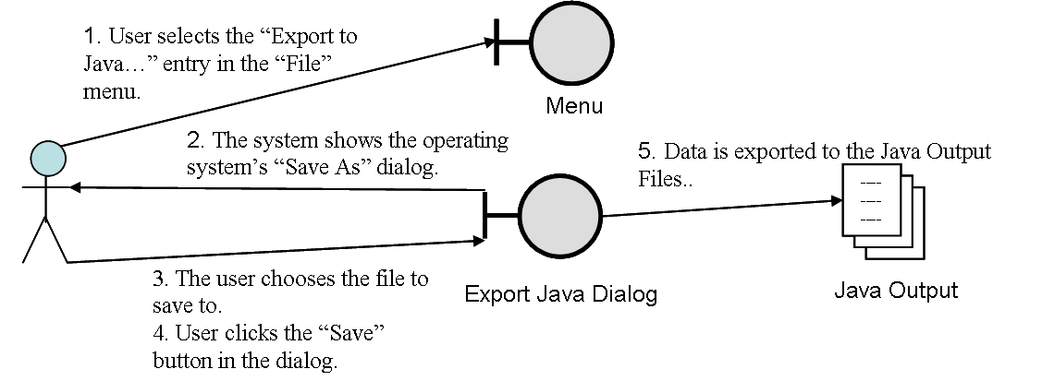
Figure 3.14-15 Export to Java Collaboration Diagram

Purpose
The purpose of Export to Java is to allow the user to save a program as a template in Java source code.

Pre-Conditions
- A view is being displayed.

Flow of Events
- The user selects the “Export to Java…” entry in the “File” menu.
- The system presents the user with the operating system’s “Save as” dialog.
- The user selects the file to save to.
- The user clicks the “Save” button in the dialog.
- The system writes the program to the file in Java source form.

Alternate Paths
3a. The user selects an existing file.
1. A dialog is displayed asking the user if they are sure they want to over-write the file.
2. User chooses option on dialog:
1. Over-write – file is overwritten by new tree file.
2. Cancel – file is not overwritten and use case returns to Step 3.
4a. The user has not selected a file.
- The system presents the user with an error dialog stating the user has not chosen a file to save to.
- The user dismisses the error dialog.
- The use case returns to Step 3.
4b. The user clicks the “Cancel” button in the dialog.
- The file is not saved and the use case terminates.
5a. The storage area runs out of space or is not write-able.
1. The use case displays a warning dialog.
2. After user acknowledges warning dialog, the use case returns to Step.

Post Conditions
If the use case was completed successfully, the active tree view is used to generate java source code in the file with the name specified during step 3. Else, the use case terminates and the system returns to its initial state before the use case.

Hide Program Element
ID: UC15
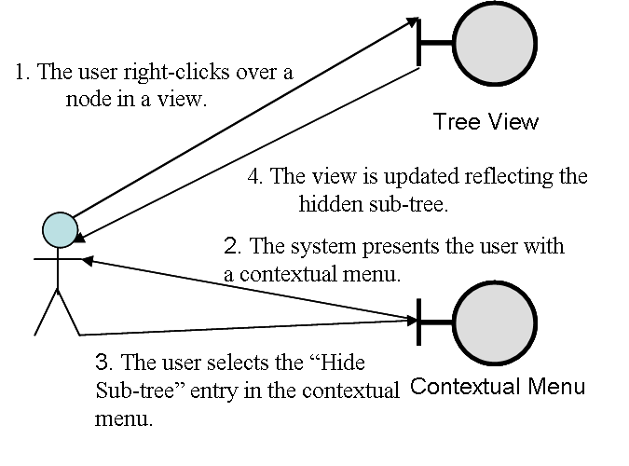
Figure 3.15-16 Hide Program Element Collaboration Diagram

Purpose
The purpose of Hide Program Element is to allow the user to collapse part of the program to one program element, freeing space in the program view.

Pre-Conditions
- A view is being displayed.

Flow of Events
- The user right clicks on a program element with children.
- The system presents the user with a contextual menu.
- The user selects “Hide Program Element”.
- The tree view is updated to reflect the fact that the node’s sub-tree is now hidden.

Alternate Paths
4a. The user clicks in any area other than the contextual menu.
- The use case terminates.

Post Conditions
If the use case was completed successfully, the active tree view is updated to reflect collapsing the program element and it’s sub-elements. Else, the use case terminates and the system returns to its initial state before the use case.

Unhide Program Element
ID: UC16
Figure 3.16-17 Unhide Program Element Collaboration Diagram

Purpose
The purpose of Expand Program Element is to allow the user to expand a program element and it’s sub-elements that has been previously collapsed.

Pre-Conditions
- A view is being displayed.

Flow of Events
- The user right clicks on a collapsed node.
- The system presents the user with a contextual menu.
- The user selects “Expand Program Element”.
- The program view is updated to reflect an expansion of the program element and its sub-elements.

Alternate Paths
1a. The user clicks in any area other than a collapsed node.
- The use case terminates
3a. The user clicks in any area other than the contextual menu.
- The use case terminates.

Post Conditions
If the use case was completed successfully, the active tree view is updated to reflect expanding the node’s sub-tree. Else, the use case terminates and the system returns to its initial state before the use case.

External Interface Specifications

Input Specifications
The TRED project saves all the Program data in a common tree XML output format. This format is known as GRXL. It outputs the data in a format that external applications will be able to generate the program in the exact tree structure. The external application may not be able to display all of the internal data, but the basic shape and structure will still be the same. The GRXL format is described in the following XML DTD which should be used when loading the XML parser to parse the data files:
<!ELEMENT grxl (attr*, nodetype*, edgetype*, hostgraph*, transformation*)>
<!ATTLIST grxl
id ID #IMPLIED>
<!ELEMENT nodetype (attr*)>
<!ATTLIST nodetype
id ID #REQUIRED
parent IDREF #IMPLIED
shape CDATA #IMPLIED
height CDATA #IMPLIED
width CDATA #IMPLIED>
<!ELEMENT edgetype (attr*)>
<!ATTLIST edgetype
id ID #REQUIRED
parent IDREF #IMPLIED
directed (true | false) "true">
<!ELEMENT hostgraph (attr*, node*, edge*)>
<!ATTLIST hostgraph
id ID #REQUIRED>
<!ELEMENT transformation (attr*, rewrite*)>
<!ATTLIST transformation
id ID #REQUIRED>
<!ELEMENT rewrite (attr*, lhsgraph, rhsgraph)>
<!ATTLIST rewrite
id ID #REQUIRED>
<!ELEMENT lhsgraph (attr*, node*, edge*)>
<!ATTLIST lhsgraph
id ID #REQUIRED>
<!ELEMENT rhsgraph (attr*, node*, edge*)>
<!ATTLIST rhsgraph
id ID #REQUIRED>
<!ELEMENT node (attr*)>
<!ATTLIST node
id ID #REQUIRED
type IDREF #IMPLIED
match IDREF #IMPLIED
label CDATA #IMPLIED
xpos CDATA #IMPLIED
ypos CDATA #IMPLIED
variable (true | false) "false"
negative (true | false) "false">
<!ELEMENT edge (attr*)>
<!ATTLIST edge
id ID #REQUIRED
type IDREF #IMPLIED
match IDREF #IMPLIED
begin IDREF #REQUIRED
end IDREF #REQUIRED
label CDATA #IMPLIED
variable (true | false) "false"
negative (true | false) "false">
<!ELEMENT attr (attrelement)*>
<!ATTLIST attr
name CDATA #REQUIRED
value CDATA #IMPLIED>
<!ELEMENT attrelement EMPTY>
<!ATTLIST attrelement
name CDATA #REQUIRED
value CDATA #IMPLIED>

For more information and an example of the basic file format, refer to Reference [4] under the section titled “GRXL”.

Output Specifications
The output file format is exactly identical to the input file format. An additional operation, however, is the ability to export Java Code. For more information on the format of Java code, refer to the Java 1.4.2 Reference.

GUI Specifications
The interface to the TRED application is through a Graphical User Interface. This interface is used to construct the Java Program Tree by adding individual program elements as nodes to a tree. Due to the fact that we are using the Swing API on Java, the windowing environment will exactly match whatever window settings the user’s operating system is currently using. Because of this, the exact look and feel of the windowing interface will change slightly based on the Operating system used. The following screenshots were taken on the Windows XP SP 2 platform.

When first invoking TRED, the user will be shown a multi-view window interface with 0 or more windows open by default. Figure 4.3-1 below shows the GUI that the user is greeted with upon invoking the TRED application under windows.

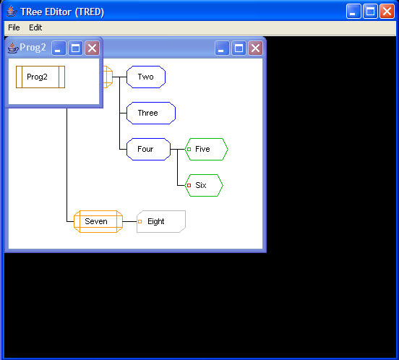
Figure 4.3-18 Main GUI interface for TRED

The user can perform many elementary actions through the menu system provided with the GUI. They can create a new program, load an existing program from a GRXL file, edit the tree data, save a current tree, or export it to Java code. The following two Figures show both the File menu and Edit menu available in TRED:

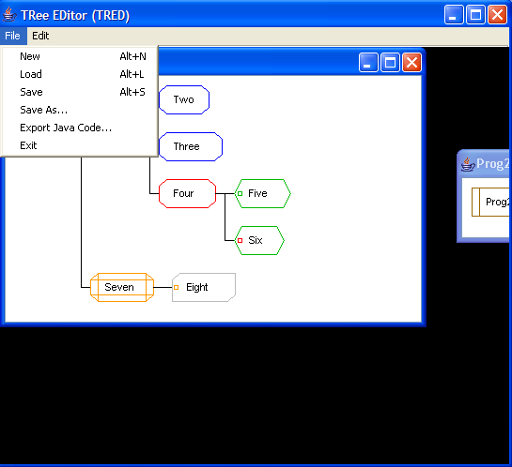
Figure 4.3-2 TRED File Menu

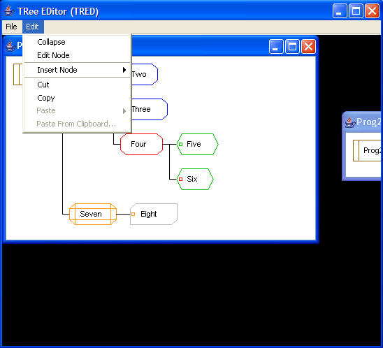
Figure 4.3-3 TRED Edit Menu

In addition, instead of forcing the user to perform all the edit commands from the edit menu, we will add a contextual menu available upon the right click of the mouse over an existing node. The following Figure demonstrates the Contextual Menu.

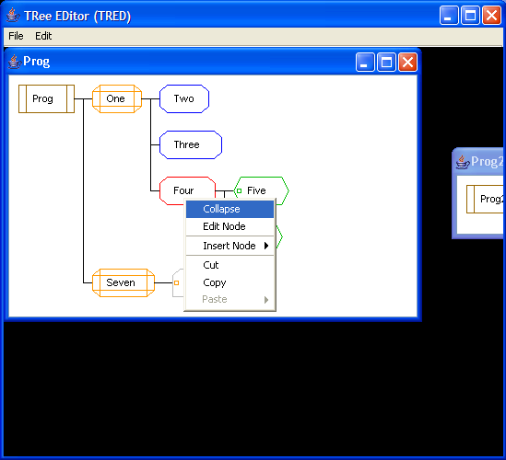
Figure 4.3-4 TRED Context Menu

Figure 4.3-5 shows the Dialog box allowing a user to add a new node. This dialog box actually changes based on the type of node a user decides to add. The node being added in the picture below is a Method node so has 2 additional fields that many other nodes do not have. These fields are the visibility of the Java Method (inside of the class) and the data type returned by the method.

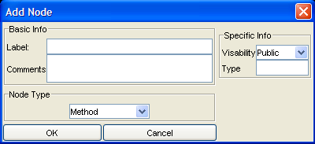
Figure 4.3-5 TRED Add Node Dialog

Figure 4.3-6 shows the Dialog box allowing a user to edit an existing node. This dialog box also changes based on the type of node a user decides to add. The node being edited in the picture below is a Class node so has 1 additional fields that many other nodes do not have, the visibility field.

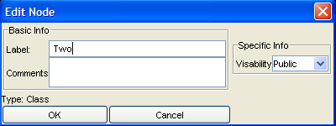
Figure 4.3-6 TRED Edit Node Dialog

When the user clicks Save or Save As under the File menu, they are presented with a Save file dialog box. Figure 4.3-7 shows the dialog box displayed.

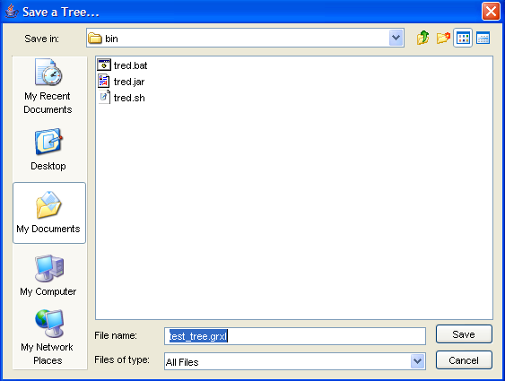
Figure 4.3-7 Save Program Tree Dialog

Figure 4.3-8 shows the Load Program dialog box invoked when the user chooses Load from the File menu.

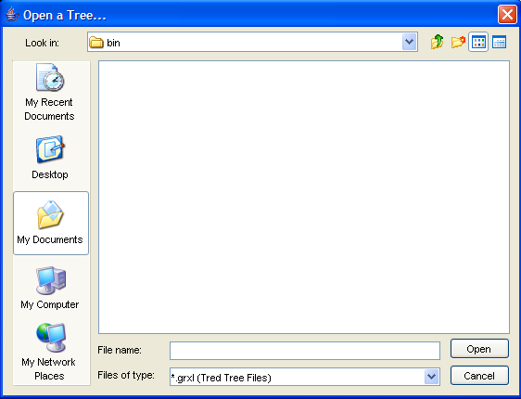
Figure 4.3-8 Load Program Tree Dialog

Figure 4.3-9 shows the Export to Java dialog box invoked when the user chooses Export from the File menu.

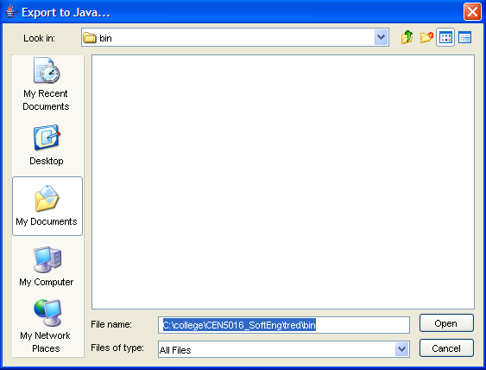
Figure 4.3-9 Export to Java Dialog

Internal Software Specifications

Architectural Overview
We’ve broken the TRED application down to 5 unique components. Each component focuses on a specific task. Figure 5.1-1 illustrates the relationship of the components with each other.

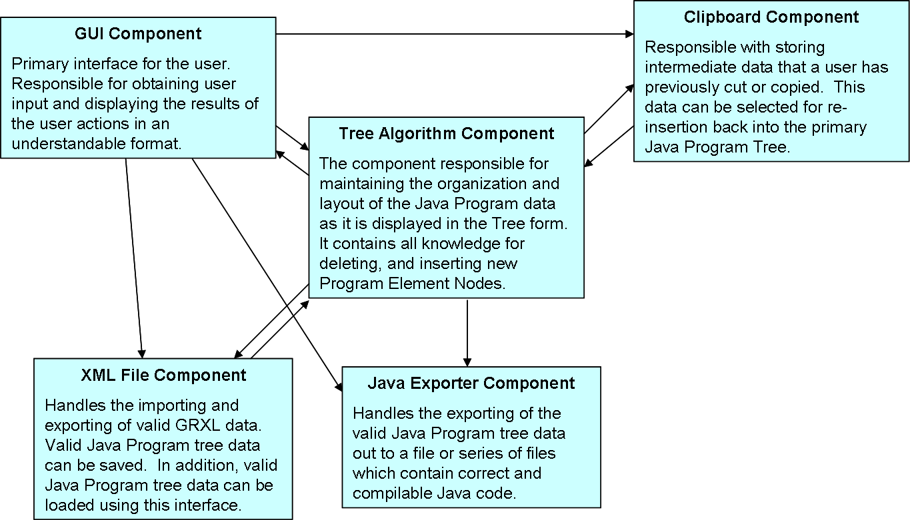
Figure 5.1-10 Component Architecture of the TRED system

The GUI Component is responsible with providing the Graphical User Interface (GUI) through which the user interacts with the TRED application. The GUI is created using the Swing Java library so that it looks similar to existing windows on the user’s desktop.

The Tree Algorithm Component consists of all classes which control how a tree is structured, shaped, and copied. It is the class that the GUI Component most interacts with. In addition, it defines how the GUI Component displays the trees defined inside of the classes.

The Clipboard Component is responsible with providing a mechanism by which users can copy and paste sub-trees between nodes. This functionality has also been modified to allow users to be able to select exactly which sub-tree in the history of the clipboard will be added during the pasting operation. This is very similar to how word processor clipboards work today. It interfaces only with the GUI Component.

The Java Exporter Component is composed of all classes and packages responsible with exporting a valid tree into Java Program Code. It interfaces with both the GUI Component as well as the Tree Algorithm Component.

The XML File Component is responsible with loading and saving the intermediate GRXL XML files which contain the tree data. The classes interact mainly with the Tree Algorithm Component but they are triggered by actions in the GUI Component.

Component Interactions
To clarify the interaction between the components, several sequence diagrams have been put together. These diagrams cover the largest operations encountered and the component interaction during that process.

Opening a New Program Tree

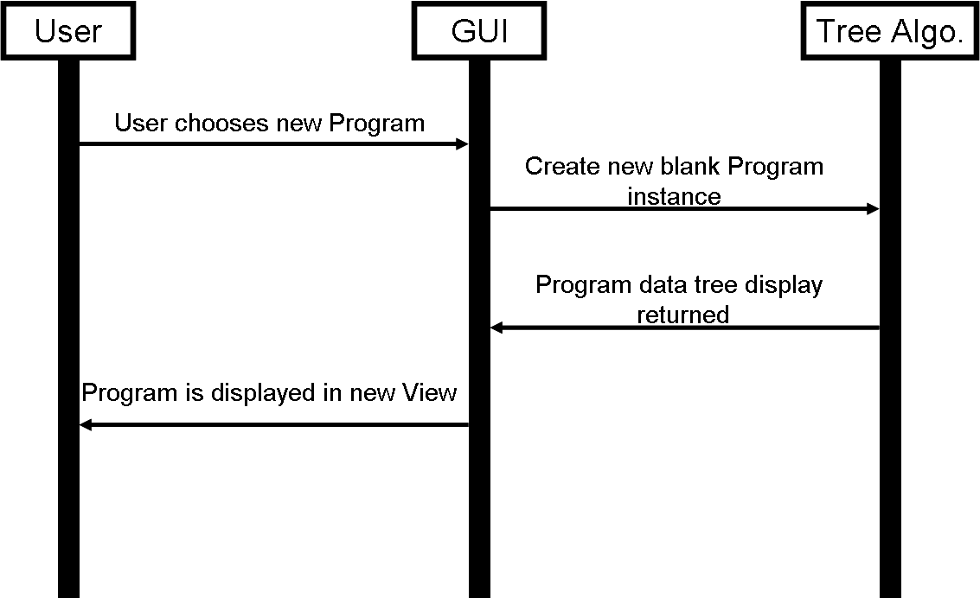

Figure 5.1-1 Opening a New Program Tree

Loading an Existing Program Tree

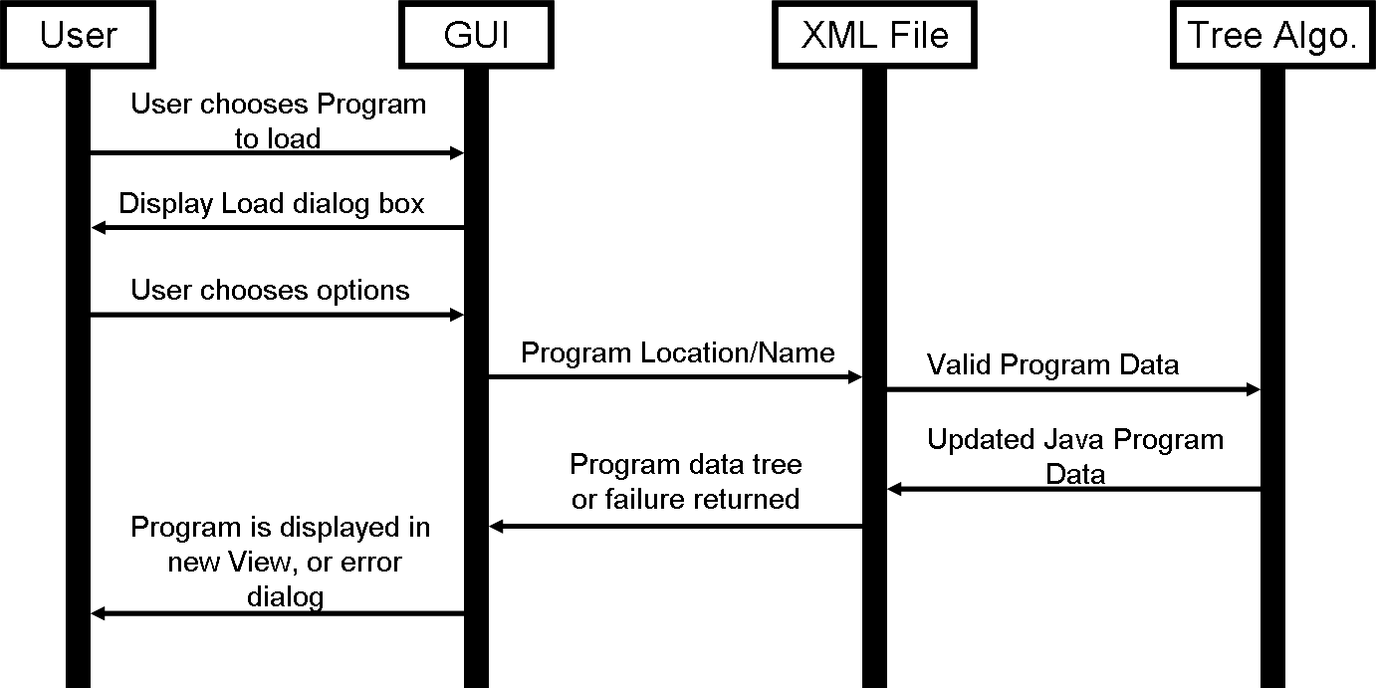

Figure 5.1-2 Loading Program Tree

Saving a Program Tree

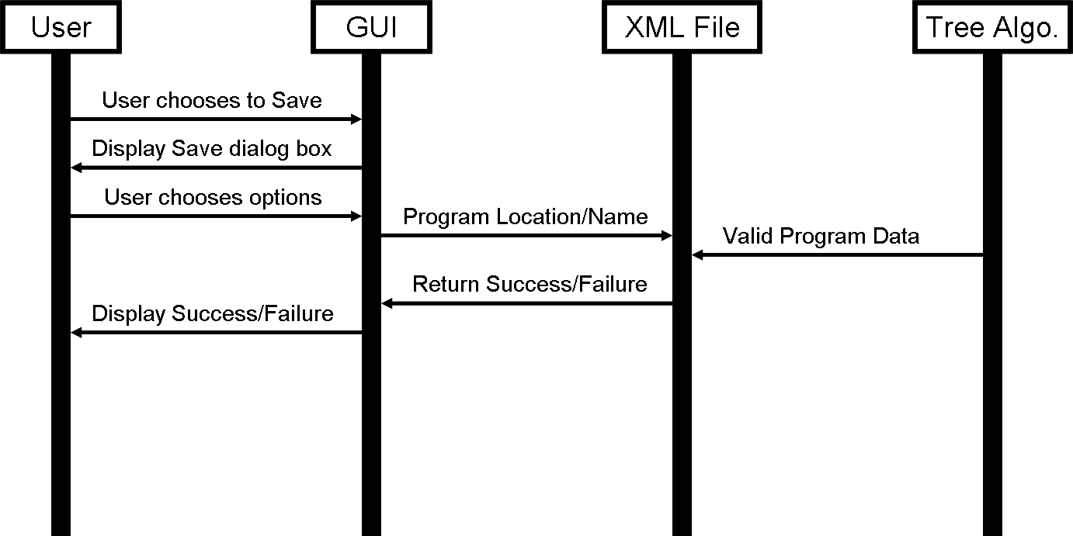

Figure 5.1-3 Saving a Program Tree

Exporting a Program Tree to Java Code

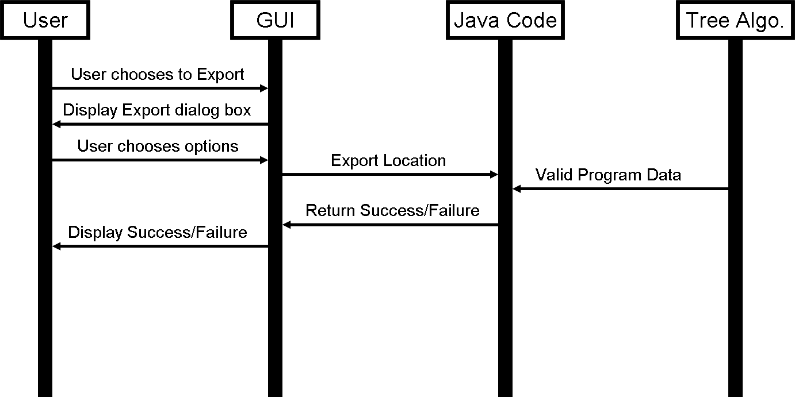

Figure 5.1-4 Exporting a Program Tree to Java Code

Cutting/Copying a Sub-tree

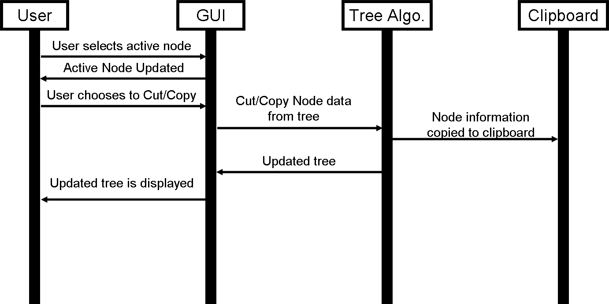

Figure 5.1-5 Cutting/Copying a Sub-Tree

Pasting a Sub-tree

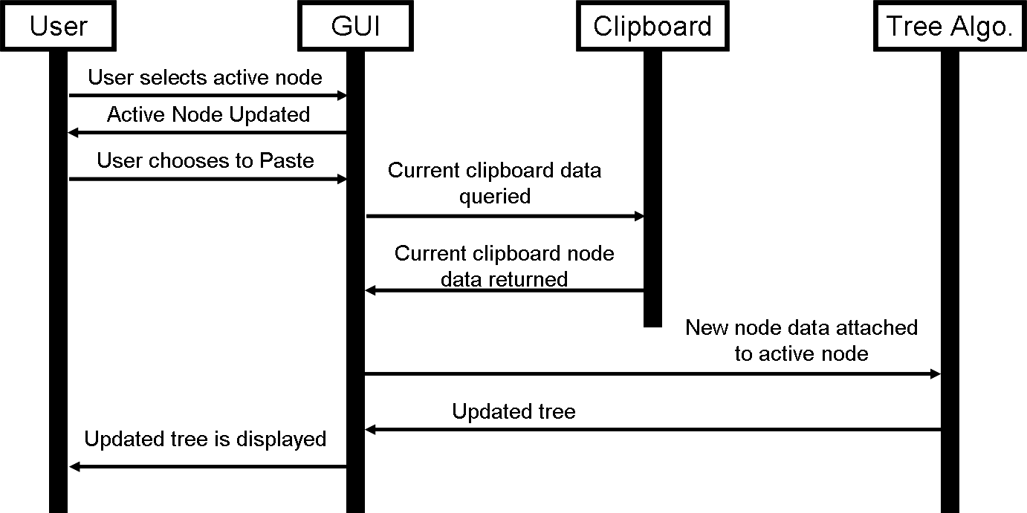

Figure 5.1-6 Pasting a Sub-Tree

Pasting a Sub-tree Using the Clipboard

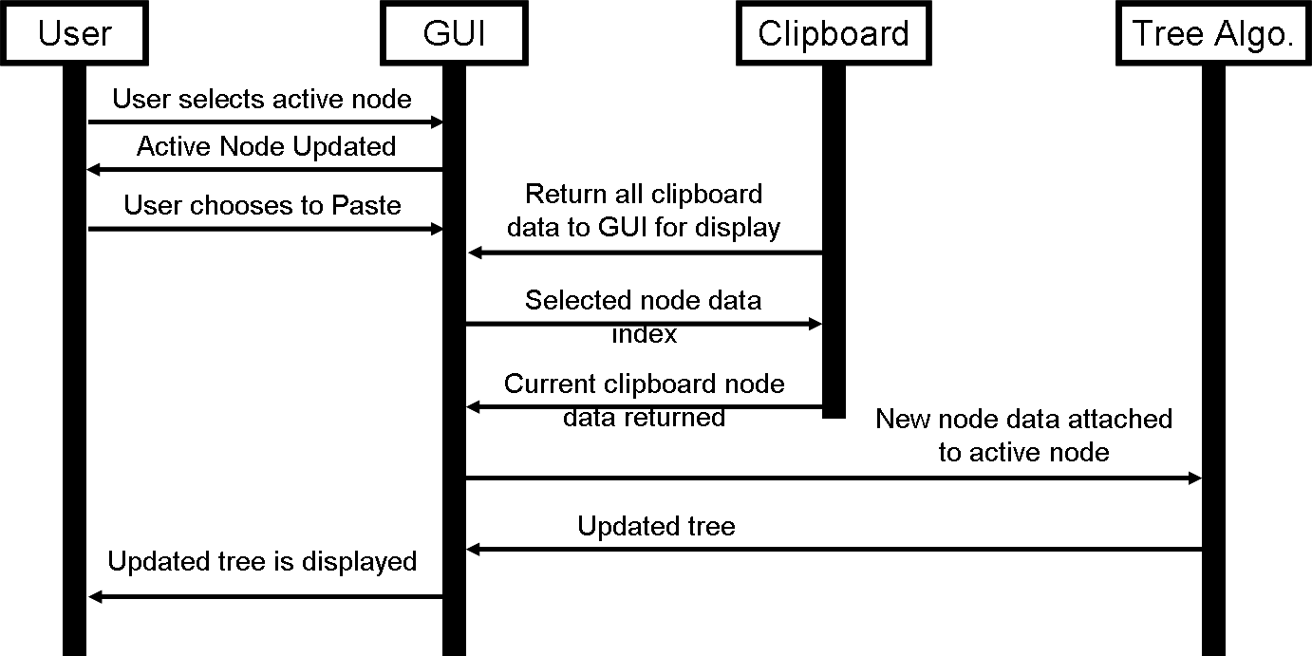

Figure 5.1-7 Pasting a Sub-Tree Using the Clipboard

Package Specifications

Package: tred.codegenerator
This package contains the base classes necessary for generating Java code for exportation.

Package: tred.codegenerator.java
This package contains the JavaCodeGenerator class which defines how to layout Java code for the code generator.

Package: tred.datastructures
This package contains the basic data types for the tree. All node classes are defined here as well as the node shaping functions. The following classes are contained in this package:
- ClassNode
- ClipBoard
- JavaProgNode
- MemberVarNode
- MethodNode
- Node
- NodeDefs
- NodeDisplayInfo
- PackageNode
- ShapeFunction
- Step

Package: tred.gui
This package contains all classes used in the GUI interface. This package is the central package to the entire application. All units tie together via this package. The following classes are contained in this package:
- ClipboardDialog
- EditNodeDialog
- Point2D
- Rect
- TredDesktop
- TreeCellRenderer
- TreeDrawer
- TreeView

Package: tred.javaexport
This package contains the top-most class which controls exporting not just to code, but specifically to java code. The only class inside of this package is JavaExporter.

Package: tred.xml
This package contains 2 classes which are used for loading and saving the intermediate XML file format (GRXL). The 2 classes are XMLExport and XMLImport.

Database Specifications
Not applicable

Class Specifications

Classes in Package tred.codegenerator
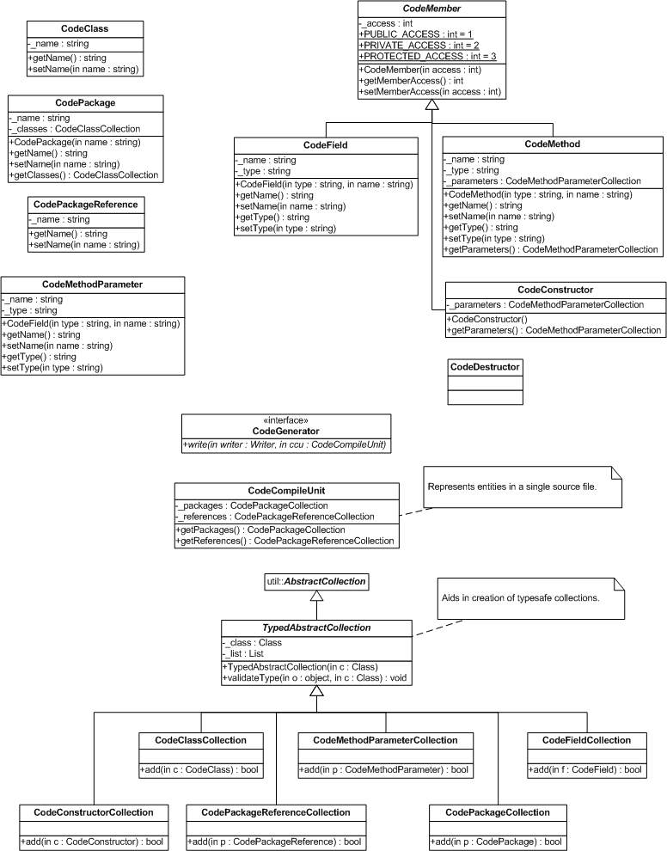

CodeClass
Represents the necessary metadata to generate a class in Java.

Table 5.4.1.1-1 CodeClass Class Interface

Method  Name | Profile/  Signature | Functional Description | Methods Called  (Other Classes)
CodeClass | (String) | Constructor. Initializes members.
getName | String | Gets the name of the class.
setName | String (String) | Sets the name of the class.
getFields | CodeFieldCollection | Gets the collection of fields contained in this class.
getMethods | CodeMethodCollection | Gets the collection of methods contained in this class.

CodeClassCollection
Holds a collection of classes. Normally contained within a CodePackage.

CodeCompileUnit
Represents the packages and types in a single source file.

Table 5.4.1.3-2 CodeCompileUnit Class Interface

Method  Name | Profile/  Signature | Functional Description | Methods Called  (Other Classes)
CodeCompileUnit |  | Constructor. Initializes members.
getPackages | CodePackageCollection | Gets the collection of packages in this source file.
getReferences | CodePackageReferenceCollection | Gets the collection packages referenced by the types in this source file.

CodeConstructor
Represents a constructor for a class.

Table 5.4.1.4-3 CodeConstructor Class Interface

Method  Name | Profile/  Signature | Functional Description | Methods Called  (Other Classes)
CodeConstructor |  | Constructor. Initializes members.
getParameters | CodeMethodParametersCollection | Gets the collection of parameters for this constructor.

CodeConstructorCollection
Represents a collection of constructors for a CodeClass.

CodeDestructor
Represents a destructor for a class.

Table 5.4.1.6-4 CodeDestructor Class Interface

Method  Name | Profile/  Signature | Functional Description | Methods Called  (Other Classes)
CodeDestructor |  | Constructor. Initializes members.

CodeField
Represents a member field in a class.

Table 5.4.1.7-5 CodeField Class Interface

Method  Name | Profile/  Signature | Functional Description | Methods Called  (Other Classes)
CodeField | (String, String) | Constructor. Initializes members.
getName | String | Gets the name of the field.
setName | (String) | Sets the name of the field.
getType | String | Gets the type of the field.
setType | (String) | Sets the type of the field.

CodeFieldCollection
Represents a collection of fields in a class.

CodeGenerator
Common interface for all CodeGenerators.

Table 5.4.1.9-6 CodeGenerator Class Interface

Method  Name | Profile/  Signature | Functional Description | Methods Called  (Other Classes)
Write | (Writer, CodeCompileUnit) | Writes a CodeCompileUnit to a Writer.

CodeMember
Represents common metadata for fields and methods in a class.

Table 5.4.1.10-7 CodeMember Class Interface

Method  Name | Profile/  Signature | Functional Description | Methods Called  (Other Classes)
CodeMember | (int) | Constructor. Initializes members.
getMemberAccess | int | Gets the access level of this member.
setMemberAccess | (int) | Sets the access level of this member.

CodeMethod
Represents a method in a class.

Table 5.4.1.11-8 CodeMethod Class Interface

Method  Name | Profile/  Signature | Functional Description | Methods Called  (Other Classes)
CodeMethod | () | Constructor. Initializes members.
getName | String | Gets the name of the method.
setName | (String) | Sets the name of the method.
getType | String | Gets the type of the method.
setType | (String) | Sets the type of the method.
getParameters | CodeMethodParameterCollection | Gets the parameters of this method.

CodeMethodCollection
Represents a collection of methods in a class.

CodeMethodParameter
Represents parameters to methods in classes.

Table 5.4.1.13-9 CodeMethodParameter Class Interface

Method  Name | Profile/  Signature | Functional Description | Methods Called  (Other Classes)
CodeMethodParameter | (int) | Constructor. Initializes members.
getName | String | Gets the name of the parameter.
setName | (String) | Sets the name of the parameter.
getType | String | Gets the type of the parameter.
setType | (String) | Sets the type of the parameter.

CodeMethodParameterCollection
Represents a collection of parameters on methods in a class.

CodePackage
Represents a package.

Table 5.4.1.15-10 CodePackage Class Interface

Method  Name | Profile/  Signature | Functional Description | Methods Called  (Other Classes)
CodePackage | (String) | Constructor. Initializes members.
getName | String | Gets the name of the package.
setName | (String) | Sets the name of the package.
getClasses | CodeClassCollection | Gets the collection of classes in this package.
equals | Boolean (Object) | Determines if two packages are equal.

CodePackageCollection
Represents a collection of packages.

CodePackageReference
Represents references to other packages in a source file.

Table 5.4.1.17-11 CodePackageReference Class Interface

Method  Name | Profile/  Signature | Functional Description | Methods Called  (Other Classes)
CodePackageReference | (String) | Constructor. Initializes members.
getName | String | Gets the name of the package referenced.
setName | (String) | Sets the name of the package referenced.

CodePackageReferenceCollection
Represents a collection of package references in a source file.

TypedAbstractCollection
Utility class to aid in the construction of type safe collections.

Table 5.4.1.19-12 TypedAbstractCollection Class Interface

Method  Name | Profile/  Signature | Functional Description | Methods Called  (Other Classes)
TypedAbstractCollection | (Class) | Constructor. Initializes members.
validateType | (Object, Class) | Ensures the object is of the proper class.

Classes in Package tred.codegenerator.java

JavaCodeGenerator
Takes a CodeCompileUnit and writes it as java code to the specified Writer. (Normally a FileWriter)

Table 5.4.2.1-13 JavaCodeGenerator Class Interface

Method  Name | Profile/  Signature | Functional Description | Methods Called  (Other Classes)
Write | (Writer, CodeCompileUnit) | Writes a CodeCompileUnit as java source to a Writer.
writePackageReference | (Writer, CodePackageReference) | Writes a CodePackageReference as java source to a Writer.
writePackage | (Writer, CodePackage) | Writes a CodePackage as java source to a Writer.
writeClasss | (Writer, CodeClasss) | Writes a CodeClass as java source to a Writer.
writeField | (Writer, CodeField) | Writes a CodeField as java source to a Writer.
writeMethod | (Writer, CodeMethod) | Writes a CodeMethod as java source to a Writer.
writeParameter | (Writer, CodeParameter) | Writes a CodeParameter as java source to a Writer.
writeAccess | String (int) | Writes an access flag as a string.

Classes in Package tred.datastructures

Class Diagram
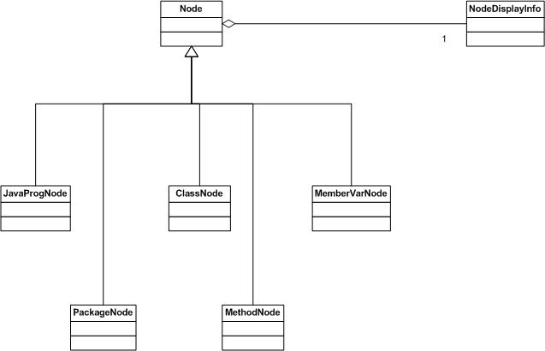

Node
The Node class is an abstract base class for all node classes to derive from. It serves as a basis for the common data among all nodes, and maintains the parent-child-sibling relationships. It also contains an instance of NodeDisplayInfo, which maintains the information necessary for displaying the node in the GUI.

Table 5.4.3.1-14 Node Class Interface

Method  Name | Profile/  Signature | Functional Description | Methods Called  (Other Classes)
Node | None | Constructor. Initializes the member fields to null.
InsertFirstChild | (Node child) | Inserts the node argument ‘child’ as the first child in this node’s subtree.
InsertLastChild | (Node child) | Inserts the node argument ‘child’ as the last child in this node’s subtree.
InsertUpperSibling | (Node sib) | Inserts the node argument ‘sib’ as the upper sibling to this node. Calls the insert method of this node’s parent.
InsertLowerSibling | (Node sib) | Inserts the node argument ‘sib’ as the lower sibling to this node. Calls the insert method of this node’s parent.
Cut | None | Removes this node from its parent, and returns a reference to this node.
GetNodeOrder | None | Returns the zero-based index of this node with respect to its siblings
GetNodeDisplayInfo | None | Returns the NodeDisplayInfo object for this node.
GetType | None | Returns an integer identifier that identifies the type of node this is (Package, Class, MemberVar, etc.)
GetChildCnt | None | Returns the number of children this node has
GetParent | None | Returns a reference to this node’s parent.
GetChild | (int idx) | Returns a child at the specified index
GetFirstChild | None | Retruns the first child of this node.
GetLastChild | None | Returns the last child of this node.
GetNode | (int x, int y) | Returns the node that lies on the point (x,y). Useful for finding a selected node in the GUI.
ReCalculateTree | () | Refactors the entire tree according to the tree spacing algorithm provided by Dr. Workman | NodeDisplayInfo::ReCalulateTree()

JavaProgNode
This node represents a java program unit. This is the root of a tree. Each view will have only one instance of this object. It will contain all other nodes in its sub-tree.

Table 5.4.3.2-15 JavaProgNode Class Interface

Method  Name | Profile/  Signature | Functional Description | Methods Called  (Other Classes)
JavaProgNode | None | Constructor. Initializes members.
Copy | None | Returns a duplicate of this node and its complete subtree | NodeDisplayInfo::  ChangeLabel()

PackageNode
This node represents a java package.

Table 5.4.3.3-16 PackageNode Class Interface

Method  Name | Profile/  Signature | Functional Description | Methods Called  (Other Classes)
PackageNode | None | Constructor. Initializes members.
Copy | None | Returns a duplicate of this node and its complete subtree | NodeDisplayInfo::  ChangeLabel()

ClassNode
This node represents a java class. It contains a field for the visibility specified for the class.

Table 5.4.3.4-17 ClassNode Class Interface

Method  Name | Profile/  Signature | Functional Description | Methods Called  (Other Classes)
ClassNode | None | Constructor. Initializes members.
Copy | None | Returns a duplicate of this node and its complete subtree | NodeDisplayInfo::  ChangeLabel()
ChangeVisibility | (int newVis) | Changes the visibility (public, protected, private) of this node.
GetVisibility | None | Returns the visibility

MethodNode
This node represents a java method. It contains fields for its visibility and return type.

Table 5.4.3.5-18 MethodNode Class Interface

Method  Name | Profile/  Signature | Functional Description | Methods Called  (Other Classes)
MethodNode | None | Constructor. Initializes members.
Copy | None | Returns a duplicate of this node and its complete subtree | NodeDisplayInfo::  ChangeLabel()
ChangeVisibility | (int newVis) | Changes the visibility (public, protected, private) of this node.
ChangeReturnType | (String newRet) | Changes the return type of this node.
GetVisibility | None | Returns the visibility
GetReturnType | () | Returns the String representation of the return type

MemberVarNode
This node represents a java member variable belonging to a class. It contains fields for its visibility and type.

Table 5.4.3.6-19 MemberVarNode Class Interface

Method  Name | Profile/  Signature | Functional Description | Methods Called  (Other Classes)
MemberVarNode | None | Constructor. Initializes members.
Copy | None | Returns a duplicate of this node and its complete subtree | NodeDisplayInfo::  ChangeLabel()
ChangeVisibility | (int newVis) | Changes the visibility (public, protected, private) of this node.
ChangeMemberVarType | (String newRet) | Changes the variable type of this node.
GetVisibility | None | Returns the visibility
GetMemberVarType | () | Returns the String representation of the variable type

NodeDisplayInfo
This class contains all of the information necessary for displaying a node in the GUI. This includes its pixel coordinates for origin, width, and height of the node. It also manages spacing the tree according to the tree spacing algorithm provided by Dr. Workman.

Table 5.4.3.7-20 NodeDisplayInfo Class Interface

Method  Name | Profile/  Signature | Functional Description | Methods Called  (Other Classes)
NodeDisplayInfo | (Node theNode) | Constructor. Sets argument ‘theNode’ as the node this displayinfo is linked to.
ChangeOrigin | (int x,int y) | Changes the origin values of this node.
ChangeLabel | (String label) | Changes the label displayed in the GUI for this node.
CollapseChildren | None | Sets this node as having ‘collapsed’ children in the GUI.
ExpandChildren | None | Reverses the changes made by ‘CollapseChildren()’
Select | None | Sets this node as ‘selected’ in the GUI.
DeSelect | None | Reverses the changes made by ‘Select()’
GetOrigin | None | Returns a Point2D object that represents the upper left corner of this node.
GetNodeWidth | None | Returns the pixel width of this node.
GetNodeHeight | None | Returns the pixel height of this node.
GetBoundingRect | None | Returns a Rect object that defines the bounding rectangle of this node and its subtree. Used by the clipboard to allocate enough space to display the subtree.
GetLabel | None | Returns the label displayed in the GUI.
IsCollapsed | None | Returns whether or not this node is ‘collapsed’ in the GUI.
IsSelected | None | Returns whether or not this node is selected in the GUI.

Classes in Package tred.gui

ClipboardDialog
This class is the GUI panel that displays on the screen to show the contents of the Clipboard. It is a extension of the Java Swing class JDialog.

Table 5.4.4.1-21 ClipboardDialog Class Interface

Method  Name | Profile/  Signature | Functional Description | Methods Called  (Other Classes)
ClipboardDialog | None | Constructor: sets the default values for the content Panel | createTreeList()  createButtonPane()
createButtonPane() | JComponent | Creates the Button Pane in the clipboard dialog
createTreeList() | JComponent | Creates the TreeList that contains the clipboard
actionPerformed() | None | The action listening method for this JDialog ActionListener, it take the appropriate path for each action of a GUI element.

EditNodeDialog
This class is the GUI panel that displays on the screen to show Edit Node dialog, it is used to edit node information as well as insert new Nodes. It creates the new nodes when the window is opened for “insertion”, and edits nodes when the window is opened for “editing”.
Table 5.4.4.2-22 EditNodeDialog Class Interface

Method  Name | Profile/  Signature | Functional Description | Methods Called  (Other Classes)
EditNodeDialog | None | Constructor: sets the default values for the content Panel | FillInfo()  MakePanel();
FillInfo | None | Fills the various text and buttons with the data for the current Node
MakePanel | JPanel | Creates the GUI elements that compose the EditNode Window. Dynamicly changes based on Node Type
getNode | Node | Returns the private member variable m_tempNode, (used for insertion)
actionPerformed() | None | The action listening method for this JDialog ActionListener, it take the appropriate path for each action of a GUI element.

Point2D
A Simple data structure used to mark a point in 2-Dimensional Space.

Table 5.4.4.3-23 Point2D Class Interface

Method  Name | Profile/  Signature | Functional Description | Methods Called  (Other Classes)
Point2D | None | Constructor: sets X and Y position of the point

Rect
This class represents a 2-dimensional rectangle. It is used to describe the dimensional bounds of a given node in the tree.

Table 5.4.4.4-24 Rect Interface

Method  Name | Profile/  Signature | Functional Description | Methods Called  (Other Classes)
Rect | None | Constructor: sets the dimensional values for the rectangle.
ChangeOrigin | None | Takes a Point2D and set the rect’s Orgin to the coordinates of the point.
ChangeWidth | None | Changes the width of the rectangle.
ChangeHeight | None | Changes the Height of the rectangle.
GetOrigin | None | Returns the rect Origin.
GetWidth | None | Returns the rect Width.
GetHeight | None | Returns the rect Height.

TredDesktop
This class extends the Java Swing GUI Class JFrame implements the standard ActionListener used for GUI action capture. It is used as the main desktop GUI element, it handles all of the main GUI functionality such as the Edit and File menu and manages of the multiple treeView windows.

Table 5.4.4.5-25 TredDesktop Interface

Method  Name | Profile/  Signature | Functional Description | Methods Called  (Other Classes)
TredDesktop | None | Constructor: Sets default locations of windows and calls Initialization methods for the various elements of the GUI. | initGUI()
initGUI | None | Creates every GUI element that is visible other than the treeView windows. | CreateMenuBar()
CreateMenuBar | None | Creates the File menu. | CreateEditMenu
CreateEditMenu | None | Dynamically creates the Edit Menu and the right click pop-up menu based on the current node selected.
addTree | None | Creates a new tree window with the tree that is passed.
getActiveTreeView | TreeView | Returns the Currently active tree window.
actionPerformed() | None | The action listening method for this JDialog ActionListener, it take the appropriate path for each action of a GUI element.

TreeCellRenderer
This class extends the Java Swing GUI Class extends JPanel implements ListCellRenderer. It is used to create the “Paste from Clipboard” list that displays the contents on the clipboard.
Table 5.4.4.6-26 TreeCellRenderer Interface

Method  Name | Profile/  Signature | Functional Description | Methods Called  (Other Classes)
getListCellRendererComponent | None | Returns the TreeCellRenderer Fully rendered. | initGUI()
paintComponent | None | Draws each tree in the clipboard

TreeDrawer
This class Draws Trees. It takes in a graphics object and a root node and Draws a tree onto the given Java Graphics Object. No calculations or changes are performed, it simply draws.
Table 5.4.4.7-27 TreeDrawer Interface

Method  Name | Profile/  Signature | Functional Description | Methods Called  (Other Classes)
DrawTree | None | Recursively draws the tree from the root node. | DrawNode
DrawNode | None | Draws the node text. | DrawGlyph
DrawGlyph | None | Draws the “Node Type” Glyph around the text of the Node.
DrawLine | None | Draws a line between two 2D points.
DrawText | None | Draws text at a given 2d point
DrawCollapsedIndicator | None | Draws the Collapsed Tree Indicator.

TreeView
This class extends the Java Swing class JInternalFrame. Each Tree view is associated with a java Tree, any actions taken on the tree are done graphically through the TreeView. The TreeViews are the child windows of the TredDesktop.

Table 5.4.4.8-28 TreeView Interface

Method  Name | Profile/  Signature | Functional Description | Methods Called  (Other Classes)
TreeView | None | Constructor: Sets the default member variables. | initComponents
initComponents | None | Initializes the GUI components, including the drawing panel and scroll bars.
getselectedNode | Node | Returns the node that is currently selected

Classes in Package tred.javaexport

JavaExporter
Represents the necessary metadata to generate a class in Java.

Table 5.4.5.1-29 JavaExporter Class Interface

Method  Name | Profile/  Signature | Functional Description | Methods Called  (Other Classes)
Export | (String, JavaProgNode) | Exports a JavaProgNode as source code in the given directory.
ReadPackages | (Node) | Reads nodes representing packages.
ReadClasses | (Node, CodePackage) | Reads nodes representing classes and adds them to the CodePackage.
ReadMembers | (Node, CodeClass) | Reads nodes representing class members and adds them to the CodeClass.

Classes in Package tred.xml

Class Diagram
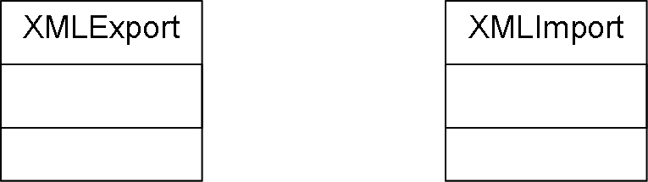

XMLExport
The XMLExport class is the class which exports the Node data (in the form of the tree) out to an intermediate XML file format known as the GRXL file format. This is a common graph format that is used outside of this project as well.

Table 5.4.6.1-30 XMLExport Class Interface

Method  Name | Profile/  Signature | Functional Description | Methods Called  (Other Classes)
XMLExport | None | Constructor. | None
PrintHeader | (BufferedWriter bufWrite) | Prints the GRXL header information to an already open file via the BufferedWriter interface | None
PrintFooter | (BufferedWriter bufWrite, String filename) | Prints the GRXL footer information to an already open file via the BufferedWriter interface. | None
PrintChildrenNodes | (BuffferedWriter bufWrite, Node nd) | Recursive method used to output a nodes children and the edges connecting those children to the node itself. | Node::GetChildCnt  Node::GetChild  Node::GetDisplayInfo  Node::GetType  DisplayInfo::GetOrigin  DisplayInfo::GetLabel  ClassNode::GetVisibiltyType  MethodNode::GetVisibilityType  MethodNode::GetReturnType  MemberVarNode:GetVisibilityType  MemberVarNode::GetMemberVarType
PrintTreeNodeInfo | (BufferedWriter bufWrite, JavaProgNode programBase) | Prints out the XML data for the top program node and it’s children. | Node::GetChildCnt  Node::GetChild  Node::GetDisplayInfo  Node::GetType  DisplayInfo::GetOrigin  DisplayInfo::GetLabel
FileExists | (String directory, String filename) | Checks to see if a file of the appropriate name exists in the given directory. | None
ExportFile | (String directory, String filename, JavaProgNode programBase) | Opens the file for exporting and exports it. | None

XMLImport
The XMLImport class is the class which imports the Node data (in the form of the tree) from an intermediate XML file format known as the GRXL file format. This is a common graph format that is used outside of this project as well.

Table 5.4.6.2-31 XMLImport Class Interface

Method  Name | Profile/  Signature | Functional Description | Methods Called  (Other Classes)
XMLImport | () | Constructor | None
startDocument | () | Function called by Xerces XML parser when a document is started. | None
startElement | (String uri, String local, String raw, Attributes attrs) | Function called by Xerces XML parser when an element is encountered. | Constructors on all node types  Node::GetDisplayInfo  DisplayInfo::ChangeLabel  DisplayInfo::ChangeID  DisplayInfo::ChangeOrigin  ClassNode::ChangeVisibility  MethodNode::ChangeVisibility  MethodNdoe::ChangeReturnType  MemberVarNode::ChangeVisibility  MemberVarNdoe::ChangeMemberVarType
endElement | (String uri, String local, String raw) | Function called by Xerces XML parser when an element is finished being defined in the XML file. | Node::GetDisplayInfo  Node::InsertLastChild  DisplayInfo::GetID  DisplayInfo::GetOrigin
characters | (char ch[], int start, int len) | Function called by Xerces XML parser when an unknown character sequence is encountered. | None
ImportFile | (String directory, String filename) | Function that imports an XML file using the Xerces XML parser and creates a Java Program Tree. | None
GetCreatedTree | () | Get the tree created during the import process. | None

Implementation Summary
Unfortunately, due to time constraints, we did not completely finish the project. Looking at the time estimates calculated for the final, it’s easy to see why. Approximately over 600 hours worth of work are required to fully complete the project based on my estimations using Schach’s chart data. Currently, we’ve only spent about 203 hours developing the project this far. Basically it would require about 3 semesters worth of work total.

Currently, users can exploit the majority of required functionality. Users can Add, Edit, Cut/Copy and Paste program element nodes inside of a Java Program tree. They can also Save and Load trees that they have created. In addition, users can also choose to export the Java Program tree as actual Java source code.

Unfortunately, due to time constraints, we were unable to finish the following things:
- Nodes are not restricted in their placement during insert, edit, or paste operations.
- Because of the above statement, if a tree isn't currently programmatically correct, it will not export properly compilable Java code.
- Verification on Linux was never completed due to our only Linux machine deciding to fail booting.
- There is a problem where in large trees random nodes do not draw at all. They are there because if you copy the parent and paste it in another location, the node that didn't appear before now appears.
- The saved/loaded GRXL files MUST be saved into the dat/ directory or another directory containing the grxl.dtd file. This is a limitation on the way we use the XML parser data.
- Certain portions of the code may not be as clean (or properly OO) as they could be due to delays in integration.

Setup information for Developers:
Currently, the application can be developed on either a Windows XP system or an Apple Macintosh running OS X Panther. Before beginning, developers should have about 400 MB of RAM available on their system to install all tools and source. If just the source, library, and data directories are needed (no tools directory) then only about 100 MB should be sufficient (that’s after both JRE and Eclipse have been installed). Developers must then install a Java Software Development Kit which will be used to interpret and run the program. The Java SDK used by all initial developers was 1.4.2-06. It is included on the CD for Windows XP and Linux. In addition to the Java SDK, developers must then install Eclipse, which is an Integrated Development Environment (IDE). We used Eclipse SDK version 3.0.1. It is also included on the CD for Windows XP, Mac OS X, and Linux. Eclipse is installed on most systems by simply uncompressing the compressed file and running the executable in the Eclipse directory.

To enable Eclipse for development:
- Start up Eclipse
- Create a new project
  - “File” -> “New”-> “Project…”
  - Choose “Java Project” and type in tred as the project name and click “Finish”.
  - Next, right click on the Project in the “Package Explorer” and choose “Import”.
  - Choose “File System” and click “Ok”
  - In the “From directory:” box, enter the directory of the src folder found on the CD.
  - Go into the src/tred directory in the dialog box and choose all the code directories and click “Finish”.
- Change the preferences to include the appropriate JRE.
  - Menu “Window” -> Preferences.
  - Select “Java” and then “Installed JREs”.
  - Select the JRE from the SDK that you installed.
  - Activate the JRE with the checkbox on the left.
  - Highlight the JRE and choose “Edit”.
  - Uncheck the “Use default system libraries”.
  - Click “Add External JARs” and navigate to the libs/xerces-2-6-2/ directory on the CD and add all the JARs in that directory.
  - Click “OK” on the External JAR dialog.
  - Click “OK” on the JRE dialog.
- Change the preferences to include Xerces in the class path.
  - Menu “Window” -> Preferences
  - Select “Java” and then “Build Path” and then “Classpath Variables”
  - Click “New” and add the “Name” of Xerces and the path to the libs/xerces-2-6-2 directory on the CD.
  - Click “OK” on the “New Variable Entry” dialog box.
  - Click OK on the Classpath Variable Dialog
- To use Eclipse further, consult the Eclipse documentation.

Setup information for End Users/Testers:
To run TRED as an end-user, the entire directory tree should be copied as is from the CD. Users should then install a Java Run-time Environment (JRE) for using to run the Java application. The developers of this project used 1.4.2-06, but any JRE after that version should be functional as well. For users running Windows XP, simply run the batch file “tred.bat” found in the /bin directory on the CD. For Mac and Linux users, simply run the “tred.sh” shell script also located in the /bin directory on the CD. The application should come up with no other problems.

